Goal is creating a model to predict the likelihood of a business or any organization where the money was used effectively. To accomplish this target and feature variables must be determined. The target variable is “IS_SUCCESSFUL” everything else is the feature variables. However, I have found that when “**SPECIAL_CONSIDERATIONS”** was dropped the model performs nominally better.

“**SPECIAL_CONSIDERATIONS” removed**

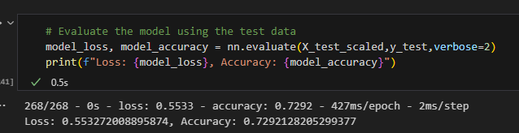

“**SPECIAL_CONSIDERATIONS” remained**

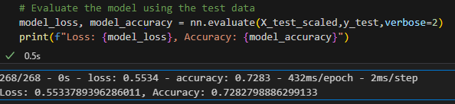

For the first model ‘Starter Code’ I chose two layers with the first layer having 10 neurons and second having five neurons.

The second model ‘AlphabetSoupCharity_Optimization’ has Four layers. The first layer has 20 neurons, the second layer has 15 neurons, the third layer has 10 neurons and fourth neuron has 5 neurons.

The main reason was creating a proper comparison between model with plenty of neuron and layers and one with less neuron and layers. The ‘Starter Code’ has less neurons and layers while ‘AlphabetSoupCharity_Optimization’ has the most neurons.

I was unable to achieve 75% accuracy. What interesting I have found that the ‘Start Code’ performed better than the ‘AlphabetSoupCharity_Optimization’ This indicates that the less neurons and layers the better the performance will be. The performance for either model was not too different from each other, this may indicate the dataset itself may not have enough relevant information to determine whether a business is successful or not.